UNIVERSITY OF COLOMBO SCHOOL OF COMPUTING

IS 2110 Data Structures and Algorithms II

Assignment 06 – BFS Traversal

Index No: 22020063

1. Correct answer is d. GAHIJBCEKD 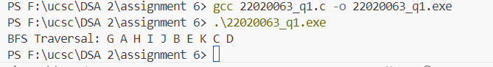

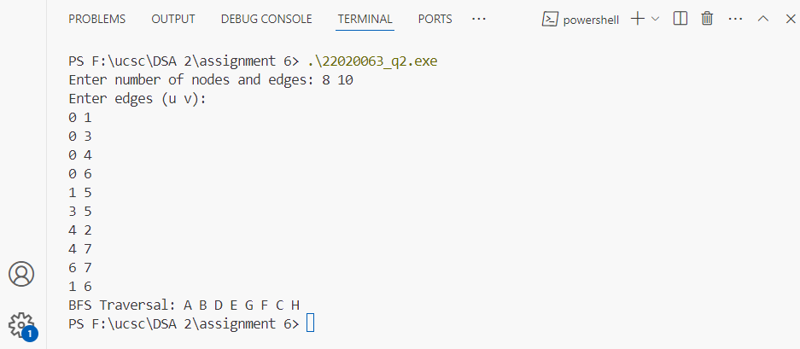

1. 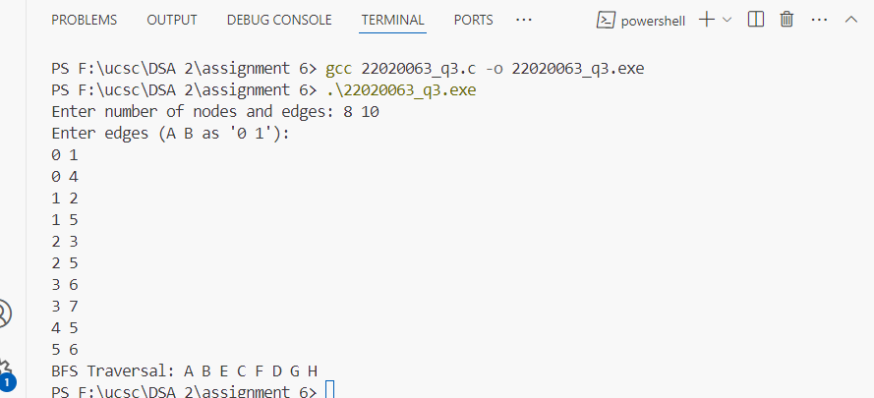
2. 